**WHAT IS A/B TESTING**

A/B testing (Sometimes called split testing) is comparing two versions of a web page to see which one performs better.

We compare two web pages by showing two variants to similar visitors at same time. The one that gives a better conversion rate wins!

100 % visitors

50% visitors

50% visitors

Variation A

Variation B

23% 11%

Conversion Conversion

When we run an A/B test, we compare one page against one or more variations that contain one major difference in an element of the control page. After a set amount of time, or visits, we compare the results to how the change affected our results.

A/B testing is actually a nickname for a variety of testing that involves single element changes across multiple variations, so it might actually be A/B/C/D testing, but it is still called A/B testing that is just a more accurate expression of one control with many variations.

Every visitor will see one version of the page or another, and we’ll measure conversions from each set of visitors.

* A/B TESTING MEANS TESTING BETWEEN A-DESIGN AND B-DESIGN.

MULTIPLE DESIGNS MAY BE THERE,IF THERE ARE 3 DESIGNS THEN THAT TESTING WILL BE KNOWN AS A/B/C TESTING OR X/Y/Z TESTING.

* A/B TESTING IS ALSO KNOWN AS MULTIVARIATE TESTING OR SPLIT TESTING.
* IF YOU ARE GRAPHIC DESIGNER,UI(USER INTERFACE) DESIGNER,THEN YOU HAVE TO KNOWLEDGE ABOUT A/B TESTING.

I.E. IF YOR ARE INVOLVE IN ANY WEB DESIGNING PROJECT, THEN KNOWLEDGE OF A/B TESTING IS MUST IMPORTANT.

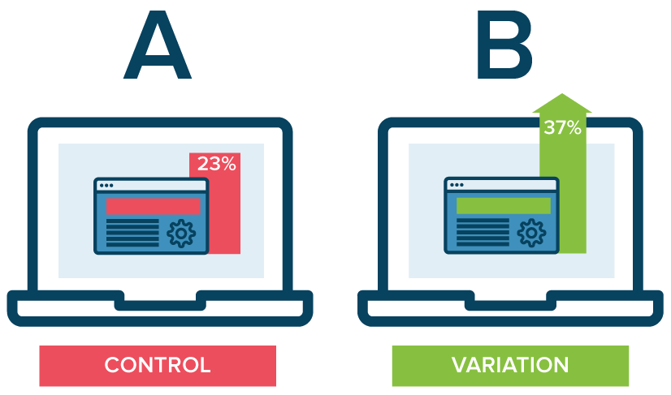

**CONTROL** is the original/unaltered version of the **site/e-mail/product** whereas **VARIATION** is the changed/modified version of the **site/e-mail/product.**

**“A/B testing takes the guesswork out of designing good calls to action. With real data, we can easily see what works and what doesn't.”**

This practice can be used for website copy, email signup forms, banners, or anything else that encourages some sort of action by the user.

|  |  |  |  |
| --- | --- | --- | --- |
| ANALYTICS | HOW MANY PEOPLE READ THIS MAIL | HOW MANY PEOPLE CLICK ON THIS | SUCCESS % |
| A  BUY1 + GET1 FREE | 7000/10000 | 2000 | 28.57% |
| B  UPTO 70% OFF | 8000/10000 | 1500 | 18.75% |
| C  FLAT 50% OFF | 6000/10000 | 4000 | 66.46% |

no.of people who read the mail

% Success = 100

No. of people who click on the link

Here success percentage of Design-C is better ,so design-C is accepted for send to customers in future.But this process is non-stoppable that means on the behalf of design-c,we have to make some other design and further A/B testing is apply.

**WHAT TO TEST**

1. **Subject and Preheader :-**

This form the only touch point before an email is opened. Its success is dictated by how closely it matches what your viewer expected when they made the decision to visit your page - whether from an ad, banner or email link etc.

Headlines will determine whether or not email will be opened. Optimal length for subject lines is 60-70 characters.

**Word order: -** The order in which we place the words in our email subject line can make a difference how people read and interpret them.

**Example:**-

* Use this discount code to get 25% off your next purchase.
* Get 25% off your next purchase using this discount code.

Here second variation is better and benefitted than first as conversion rate is more than first.

Test Ideas:

• Long vs. short.

• Positive vs. negative.

• Benefit oriented vs. feature oriented.

• Single headline vs. primary and secondary supporting copy.

1. **Images: -** Adding images to web pages can be a very powerful tool to generate more engagement from readers. If we want to get clear idea on whether or not images are adapted to our email marketing efforts, we just have to test Version A with images and version B with no images and we will get which one is better.

**Example: -** In this case study removing the image actually resulted in Version B having more conversions than version A.

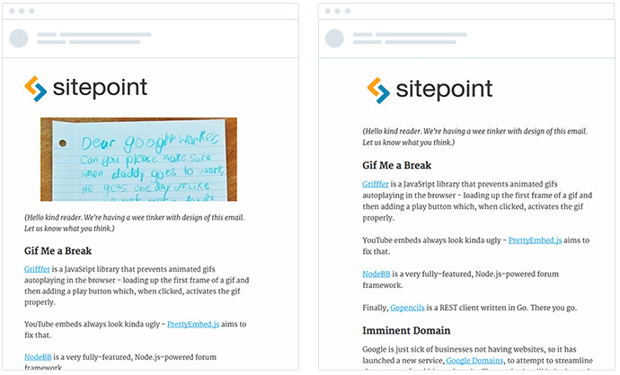

#### Style:-

There are many different types of visuals we can include in your email campaigns.

To illustrate, consider these two emails from different Campaign Monitor customers, both of which are using email to announce new features in their products.

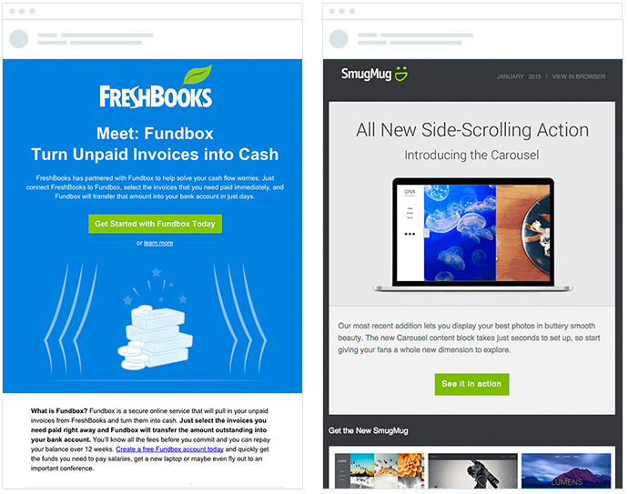[Freshbooks](https://www.freshbooks.com/) chooses to use a drawing style in their campaigns that closely mimics the visual style seen on their website, while [SmugMug](https://www.smugmug.com/) opts to show a screenshot of the interface displayed inside a Mac laptop.

Which works best? It completely depends on our audience and layout of our campaign, and the only way to know which will work for it we have to A/B test it.

1. **Personalization:-**

According to [studies](https://www.campaignmonitor.com/blog/email-marketing/2016/01/70-email-marketing-stats-you-need-to-know/), including personalization in your email campaigns can increase click-through rates by over 14%.

The team at [Dropbox](https://www.dropbox.com/) realize this and leverage it to their advantage, including the subscriber’s company name in the email to make the invite more relevant to the subscriber and increase the chance they’ll attend the event.

To check whether this will work for our page we have to a/b test it.

1. **Tone:-**

 The tone we use in the body copy of your email campaigns can have a big effect on the number of click-troughs we receive.

[Studies show](https://www.campaignmonitor.com/blog/email-marketing/2014/11/positivity-email-click-through-rate/) that when we incorporate positivity into our copy, we engage our reader’s brain in a much more powerful way, enabling them to easily understand our key messages and increasing their motivation to click-through and purchase your product.

This will [increase our email conversion rate by 22%](https://www.campaignmonitor.com/blog/email-marketing/2014/11/positivity-email-click-through-rate/).

1. **Call to Action(CTA):-**

It’s what we want our visitors to do (and nothing else). If people aren’t converting your call to action may be in need of updating.

CTA’s should be very descriptive, describing exactly what will happen when clicked. A good tip when writing your CTA is to finish the phrase “I want to...”, for example:

I want to...

•Read More

•Subscribe to the Newsletter

•Download the eBook etc.

**Example**:- This example from our blog shows a series of case studies on how to write CTA’s that convert including a simple one (shown below), where they achieved a 38% lift in conversions by changing a single word.

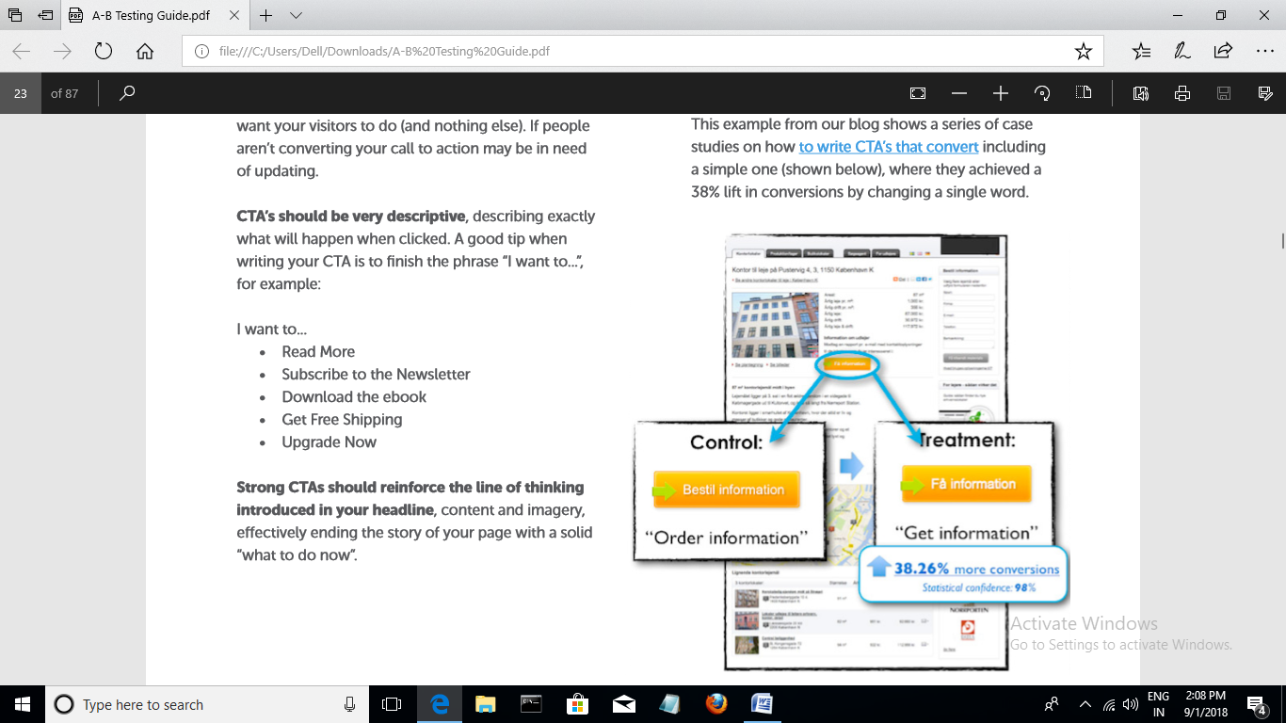

**We can also A/B test:-**

* Text vs. Buttons.
* Social proofs.
* Media mentions and links.
* Color of button or images.
* Content of page Etc.

### **A/B Testing Process**

The following is an A/B testing framework you can use to start running tests:

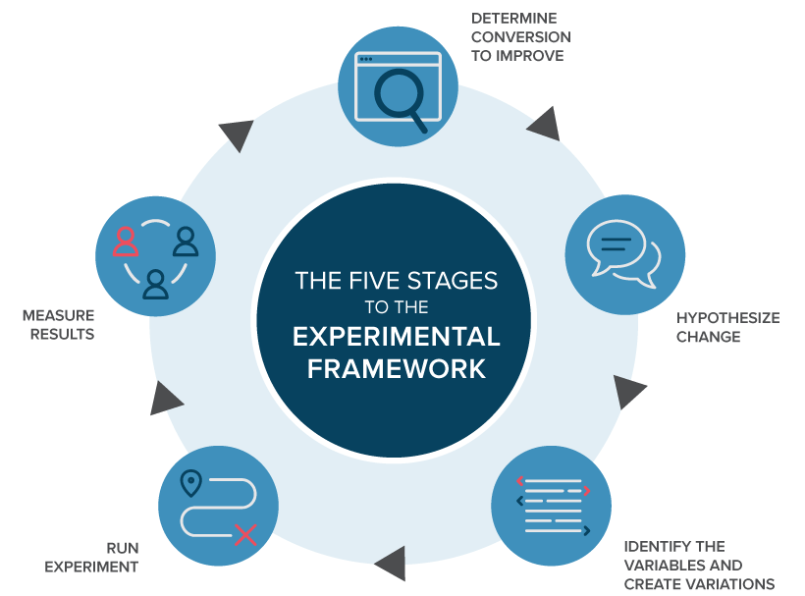

* **Collect Data: Analytics** will often provide insight into where you can begin optimizing. Look for pages with low conversion rates or high drop-off rates that can be improved.
* **Identify Goals:**  Conversion goals are the metrics that we are using to determine whether or not the variation is more successful than the original version. Goals can be anything from clicking a button or link to product purchases and e-mail signups.
* **Generate Hypothesis:** Once we've identified a goal we can begin generating A/B testing ideas and hypotheses for why we think they will be better than the current version.
* **Create Variations:** Using your A/B testing software (like Optimizely), make the desired changes to an element of your website or mobile app experience. This might be changing the color of a button, swapping the order of elements on the page, hiding navigation elements, or something entirely custom.
* **Run Experiment:** Kick off the experiment and wait for visitors to participate! At this point, visitors to our site or app will be randomly assigned to either the control or variation of our experience. Their interaction with each experience is measured, counted, and compared to determine how each performs.
* **Analyze Results:** Once our experiment is complete, it's time to analyze the results. A/B testing software will present the data from the experiment and show you the difference between how the two versions of your page performed, and whether there is a [statistically significant](https://www.optimizely.com/optimization-glossary/statistical-significance/) difference.

**Uses of A/B Testing in E-Mail Marketing:-**

E-mail Marketing is all about maximizing our open, click and response rates while generating as many leads and sales as possible for given email. Email marketing channel is both highly profitable and affordable.

**Uses**

* It will improve our open and click through rates: - This means that we will not only get more views but also more clicks to our website or online forms.
* It will increase conversion rate.
* We will know what works for our audience: - In this we can made an email that will fit our prospects and generate more engagement.
* Saves time and money: - using A/B testing, we’ll save time and money by quickly identifying the recipe for success in our given by implementing incremental changes that will lead to better results.
* It gives us data to backup what we think might be successful.
* We can measure the effect of changes we made: - Advanced analytics can be installed and evaluated for each variation.

## **Guidelines for effective A/B testing:-**

The first step in setting up an effective A/B test is to decide what we’ll test. While you we want to test more than one thing, it’s important to only test one thing at a time to get accurate results. Things you might consider testing include:

* **Offers** - Experiment with the medium of the offer. You might test an eBook versus a whitepaper or video.
* **Copy** - Experiment with the formatting and style of the content. You could test plain paragraphs versus bullet points or a longer block of text vs a shorter block of text.
* **Email Sender** - Try sending the email from an employee's email address instead of a generic department address.
* **Image**- Try out different images to see how the conversion rate is influenced.
* **Subject Line** - Play around with the length of the subject line or add personalization.
* **Whole Email**- The fastest way to achieve drastic results and produce a landing page that drives a lot of conversions is to test the entire email. Make iterations to the whole email that affect image placement, subject line, and its copy. Once you have a statistically significant result pointing to the variation that performed better, you can continue optimizing through smaller tweaks.
* **Call to Action (Example : “Buy Now!” vs “See Plans & pricings”)**
* **Layout of the Message:** (single column vs double column or different placements for different elements)
* **Specific Offers**: (Save 20% vs FREE SHIPPING)

There are various email campaign softwares that have built-in tools for A/B testing such as Campaign Monitor, MailChimp and Active Campaign.